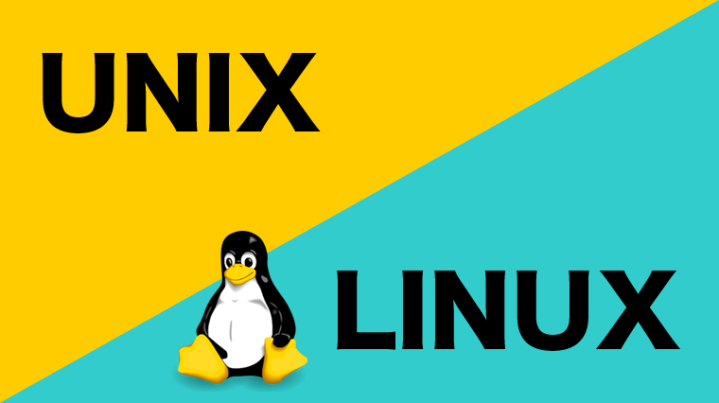

**THE DEVELOPMENT OF OPERATING SYSTEMS IN**

**TECHNOLOGY**

**Willie Conway**

**Park University**

**OPERATING SYSTEMS IN TODAYS WORLD**

We use computers every single day from laptops, desktops, tablets and smartphones. They appear convenient for everyday use, rather your completing homework assignments, developing a program, traveling, skyping friends and family or a fan of social media, the use of computer technology has impacted you in some way. Although, most of society has learn to adapt quickly to this new information age that were living in, many of us are still wondering how did we get to this point? How do these forms of technology really work? Well, the truth begins with user-interface.

The term user interface is arranged from when a user interacts with a computer system. Computers utilize operating systems, which is software that manages computer hardware and software resources to developed programs. You may know a couple of them as the half-eaten apple, a penguin logo, a square window with various colors and four big letters that spell out U, N, I, X. That’s right, I’m talking about Apple, Windows, Linux and Unix. Windows and Mac Operating System (OS) are the most common, that many would recognize do to their popularity, but the cream of the crop begins with Linux and Unix.

**The History of Linux and its Relationship with Unix**

Unix is an operating system that’s infamously known for its multi-user and multi-tasking ability. According to the Diffen Community, it’s primarily used to manage internet servers and workstations. It’s the home of many known tech companies today such as Intel, Hewlett Packard (HP), and Oracle. It was developed in 1969 by a group of AT&T employees at Bell Labs, along with Ken Thompson and Dennis Ritchie. Two outstanding Bell Lab employees who worked on “Multics,” a predecessor to Unix that went poorly. Unix operated under the “C” language and was designed to be a multitasking time system that promoted time-sharing. Both Thompson and Ritchie were optimistic about spreading Unix globally but needed way (Diffen Community, 2019).

William L. Hosch of the Britannica Community disclosed that in 1985, an American free software movement activist and programmer by the name of Richard Stallman created the Free Software Foundation and developed the GNU project. GNU was a Unix-like operating system. Stallman was a MIT hacker that believed in sharing computer code and software freely (Hosch, 2019). He believed that programmers and engineers should have the right and freedom to study, modify, distribute and use software.

The Diffen Community expressed that it was in 1991 when a computer science student by the name of Linus Torvalds, saw an opportunity to create an operating system of his own. Do to him having free access to all the tools he needed, all thanks to Richard. Torvalds utilize a kernel, which is the core of a computer operating system, and molded it into a Unix-like OS. This specific operating system supported libraries and various system utilities all of which were needed for an operating system. Since Torvalds develop his own custom OS from Richards GNU project, he decided that this OS was going to be free. Though he never imagined it growing into something, he was curious to see if people would really test it out. He released the OS in 1991 of September and called it Linux (Diffen Community, 2019).

Linux is an open source operating system kernel that’s the home of many software programs game development, mainframes and applications. In other words, it’s a pile of code that developers, corporations and businesses utilize, to form, shape and create any operating system of their choice. Do to Linux being an open source that’s utilized all over the world, it still remains at the cost of nothing to download. Developers and programmers all over the world supply their code to Linux to improve its capability. Linus Torvalds began developing the operating system kernel, which today we call “Linux” as a hobby, do to his love for coding.

Over the years, much of society still believes that Linux is just a copy of Unix, as the similarities come in comparison with each other. But what really is the relationship between the two? The relationship between Linux and Unix is that each operating system was a development in process, little the less an experiment. The main relationship between the two, is the platform. Each of the operating systems have some form of user base, file system support, and graphical user interface (GUI). What was great about each of these operating systems, was that each promoted multi-user ability, multi-tasking environments, and a great link of security. Kathleen Juell of the Digital Ocean Community stated that, “Linux has a monolithic kernel, like Unix, but it can dynamically load and unload kernel code on demand. Unix is oriented around round principles of clarity, portability, and simultaneity” (Juell, 2017). Linux has many of the same components as Unix, but it seems as if it became a better development after learning from Unix’s history. When Unix was presented not many tools were available as they were when Linux arrive on the seen which caused for it to excel further. Back then we weren’t living in the information age, programmers and engineers were still experimenting and testing new projects. Now, we live in a world where everything is embraced by Technology. Technology and innovation that all started from the evolution of a kernel.

**References**

Diffen Community. (2019). Linux vs Unix - Difference and Comparison | Diffen. Retrieved January 18, 2019 from: <https://www.diffen.com/difference/Linux_vs_Unix>

Hosch, W. (2019). Richard Matthew Stallman | American computer programmer. Retrieved January 18, 2019 from: <https://www.britannica.com/biography/Richard-Matthew-Stallman>

Juell, K. (2017). History of Linux | DigitalOcean. Retrieved January 18, 2019 from: <https://www.digitalocean.com/community/tutorials/brief-history-of-linux>